VISVESVARAYA TECHNOLOGICAL UNIVERSITY
BELAGAVI


A Mini Project Report on
“SOS RESCUE APPLICATION”
Submitted in the partial fulfillment for the requirements for the conferment of degree of
BACHELOR OF ENGINEERING
In

COMPUTER SCIENCE AND ENGINEERING

By
Ms. AYUSHEE SOOKDEB USN: 1BY19CS191

Mr. GAJEELEE ROHAN PRANAV USN: 1BY19CS194

Under the guidance of
Dr. Srivani P Mrs. Vidya Pai
Assistant Professor Assistant Professor
Department of CSE, BMSIT&M.



DEPARTMENT OF COMPUTER SCIENCE AND ENGINEERING

B.M.S. INSTITUTE OF TECHNOLOGY & MANAGEMENT
Yelahanka, BENGALURU-560064
2021-2022

B.M.S INSTITUTE OF TECHNOLOGY & MANAGEMENT
Yelahanka, BENGALURU-560064

DEPARTMENT OF COMPUTER SCIENCE & ENGINEERING

CERTIFICATE

This is to certify that the Mini Project work entitled “RAILWAY RESERVATION” is a bonafide work carried out by Ms. AYUSHEE SOOKDEB and Mr. ROHAN PRANAV GAJEELEE (1BY19CS191 AND 1BY19CS194) in partial fulfillment for the award of Bachelor of Engineering Degree in Computer-Science and Engineering of the Visvesvaraya Technological University, Belagavi during the year 2021-22. It is certified that all corrections/suggestions indicated for Internal Assessment have been incorporated in this report. The Mini project report has been approved as it satisfies the academic requirements in respect of project work for the B.E Degree.

_________________ ______________ __________________
Signature of the Guide1 Signature of the Guide2 Signature of the HOD
Dr. Srivani P Mrs. Vidya Pai Dr. Thippeswamy

Name of the Examiners Signature with Date
1.

2.

INSTITUTE VISION
To emerge as one of the finest technical institutions of higher learning, to develop engineering professionals who are technically competent, ethical and environment friendly for betterment of the society.

INSTITUTE MISSION
Accomplish stimulating learning environment through high quality academic instruction, innovation and industry-institute interface.

DEPARTMENT VISION
To develop technical professionals acquainted with recent trends and technologies of computer science to serve as valuable resource for the nation/society.

DEPARTMENT MISSION
Facilitating and exposing the students to various learning opportunities through dedicated academic teaching, guidance and monitoring.

PROGRAM EDUCATIONAL OBJECTIVES
- Lead a successful career by designing, analyzing and solving various problems in the field of Computer Science & Engineering.
- Pursue higher studies for enduring edification.
- Exhibit professional and team building attitude along with effective communication.
- Identify and provide solutions for sustainable environmental development.

Mobile Application Development– 18CSMP68 - Course Outcomes (COs) w.r.t this Mini Project
MADL | Developing a working application using appropriate software and resources

Project to Program Outcomes (PO) Mapping
Project Name: SOS Rescue Application
COURSE | PO1 | PO2 | PO3 | PO4 | PO5 | PO6 | PO7 | PO8 | PO9 | PO10 | PO11 | PO12
MADL | ✓ | ✓ | ✓ | ✓ | ✓ |  |  | ✓ | ✓ | ✓ | ✓ | ✓

Program outcomes (POs):
PO1 | Engineering knowledge: Apply the knowledge of Mathematics, Science,  Engineering fundamentals and an engineering specialization to the solution of complex engineering problems
PO2 | Problem analysis: Identify, formulate, review research literature, and analyse  complex Engineering problems reaching substantiated conclusions using first principles of mathematics, Natural sciences and engineering sciences
PO3 | Design/development of solutions: Design solutions for complex engineering problems and design system components or processes that meet the specified needs with appropriate consideration for the public health and safety, and the cultural, societal, and environmental considerations.
PO4 | Conduct investigations of complex problems: Use research-based knowledge and research methods including design of experiments, analysis and interpretation of  data, and synthesis of the Information to provide valid conclusions
PO5 | Modern tool usage: Create, select, and apply appropriate techniques, resources, and modern Engineering and IT tools including prediction and modelling to complex  engineering activities with an understanding of the limitations.
PO6 | The engineer and society: Apply reasoning informed by the contextual knowledge to assess societal, health, safety, legal and cultural issues and the consequent  responsibilities relevant to the professional engineering practice.
PO7 | Environment and sustainability: Understand the impact of the professional  engineering solutions in societal and environmental contexts, and demonstrate the knowledge of, and need for Sustainable development
PO8 | Ethics: Apply ethical principles and commit to professional ethics and responsibilities and norms of the engineering practice.
PO9 | Individual and team work: Function effectively as an individual, and as a member or leader in diverse teams, and in multidisciplinary settings
PO10 | Communication: Communicate effectively on complex engineering activities with the engineering Community and with society at large, such as, being able to comprehend and write effective reports And design documentation, make effective  presentations, and give and receive clear instructions.
PO11 | Project management and finance: Demonstrate knowledge and understanding of the Engineering and management principles and apply these to one’s own work, as a member and Leader in a team, to manage projects and in multidisciplinary  environments.
PO12 | Life-long learning: Recognize the need for, and have the preparation and ability to engage in independent and life-long learning in the broadest context of  technological change.

Project to Program Specific Outcomes (PSO) Mapping

Project Name: SOS Rescue Application
COURSE | PSO1 | PSO2
MADL | ✓ | ✓

Program Specific Outcomes (PSOs):
PSO1 | Analyze the problem and identify computing requirements appropriate to its solution.
PSO2 | Apply design and development principles in the construction of software systems  of varying complexity.

ABSTRACT

As the name suggests SOS Rescue Application is software that can be used for the safety of people. It is fully based on the concept of helping the people who feel they might be in danger or if they feel someone else might be needing some help. Usually, if someone is in danger, it is quite difficult for to call anyone and it might take some time for the necessary authorities to reach that location quickly Therefore the SOS Rescue Application was designed. After the release of this system, the with the simple press of a button, the owner of the phone can call for help instantly. It might be either to the authorities or an emergency contact that has to be already pre-programmed in the application. Our project introduces SOS Rescue Application with an objective to make the calling for help easier and fast while also alerting anyone nearby. This mini-project explores how computer technology can be used to solve the problem of personal safety of a user.
The main features provided by this software are as follows:
- User Authentication
- Panic Button or simple Shake the Phone to send alerts
- Add Emergency Contact
- Send Location
- Call Emergency Contact
- Loud Sound

This project is dedicated to model existing safety applications that aim at development of
the application that facilitates the user to manage their safety and it is also an initiative to make them feel safer.

ACKNOWLEDGEMENT

While bringing out this project to its final form, I came across a number of people whose contributions in various ways helped my field of research and they deserve special thanks. It is a pleasure to convey my gratitude to all of them. First and foremost, I would like to express my deep sense of gratitude and indebtedness our Professors, for their invaluable encouragement, suggestions and support from an early stage of this research and providing us extraordinary experiences throughout the work. Above all, their priceless and meticulous supervision at each and every phase of work inspired us in innumerable ways.

I specially acknowledge them for their advice, supervision, and the vital contribution as and when required during this research. Their involvement with originality has triggered and nourished my intellectual maturity that will help me for a long time to come. I am proud to record that I had the opportunity to work with an exceptionally experienced Professors like them.

I am obliged to Principal, Dr. MOHAN BABU G N, BMS Institute of Technology & Management for his support and co- operation that is difficult to express in words.
I heartily thank our Head of the Department, Dr. Thippeswamy, Dept. of Computer Science and Engineering, BMS Institute of Technology & Management for her constant encouragement and inspiration in taking up this Mini project.
I gracefully thank Project guides, Dr. Srivani P, Associate Professor, Dept. of Computer Science and Engineerin and Mrs. Vidya Pai, Associate Professor, Dept. of Computer Science and Engineering, for their encouragement and advice throughout the course of the Project work.

Finally, I am deeply indebted to my mother, my father and to my family members as well as friends for their moral support and continuous encouragement while carrying out this study.

AYUSHEE SOOKDEB
1BY19CS191

GAJEELEE ROHAN PRANAV
1BY19CS194

CONTENTS
CHAPTERS | SUB CHAPTERS | PAGE NUMBERS
- Introduction | - Introduction  - Background | 6
- Literature survey | - Literature Survey  - Motivation | 9
- Software Requirements Specifications | - Functional Requirements  - Non-Functional Requirements | 10
- Existing System | - Existing System  - Limitations of Exisitng System  - Proposed System
- Design | - Flow Chart | 12
- Implementation | 5.1 Implementation with screenshots
- Conclusion and Future Enhancement | - Conclusions  - Future Enhancements | 16
- References |  | 17

CHAPTER 1 - INTRODUCTION

  - INTRODUCTION
Personal safety is a basic human right that no one should have to live without. Safety is the prime concern in today’s world considering the jump in the number of incidents and crime rates especially against women, like in the metro cities where people have to stay till late at night. Moreover, at least 50% of the world’s population faces threats to their personal safety every day. People of all ages and backgrounds are constantly dealing with unsafe situations, whether when walking home alone, riding in taxis, or simply existing in public places. The primary issue in handling these cases by the police lies in constraints preventing them from responding quickly to calls of distress, and these constraints include not knowing the location of the crime and not knowing the crime is occurring at all. Moreover, at the victim’s end, reaching the police assuredly and discreetly is a challenge. Even after taking certain actions, the Government is not able to provide any security. Hence, one of the ways to solve this is through self-defence, where people can protect themselves by using a technology-based application. Most of the population nowadays carry their smartphone with themselves, so it is necessary to have at least one safety application. With all this in mind, we are proposing this application which will overcome these issues in the fastest and simplest way for anyone to use.

The most primary part of these applications is GPS tracking, sending SMS, safe locations In this proposed project, to ensure safety and security, an Android based application has been developed to handle things during a crisis. This system overcomes the problems like poor network problems, feasibility, supportive and real time monitoring of things. In this project GPS tracking along with the location alert message sends location-based information. The project also integrates panic button or shaking system so that the live location is sent and emergency contacts or authorities can be contacted with just a press of a button or simply by shaking the phone. Moreover, there is a loud sound that is emenated that will alert nearby people to send help. It provides self defence tips and SMS alert when a person is in danger. For the main functionality of the app to begin, at first the user has to make sure that the app is on when they step out. Whenever any unfortunate problem happens, he/she has to press SOS or can shake the device to give the command for starting the main function of the app. After beginning the main function, it will send emergency message with victim’s current location to the registered contact and will also call the police. The user also has the ability to turn it off the app to stop its functionalities.

1.2. BACKGROUND
Android app can sink the information in real time, in order that the assistance is often provided. Several researches are going on this and have designed wristbands, smart watch, etc. Titan Company has designed a primary smart await women's safety called “ACT – App-Enabled latitude and longitude Tracker” which has been used by the user and triggers and alerts when that recipient who has worn the watch is in danger.

CHAPTER 2 - LITERATURE SURVEY

2.1. LITERATURE SURVEY
Engineers developed a safety device to protect women from vulnerable activity and lonely traveling on the road using IoT based on the fingerprint security method. This device alerts closure people as well as a police station, if any wrong or criminal movements with that women. Saikumar, who is another developer proposed a gadget to locate a risky place and many threats for women through IoT modules like Arduino UNO controller. So this controller is also integrated with Bluetooth device, teaser and Android app. But the overall system is tracked the risky spot of the women with the help of GSM and GPS module. Another creator has designed an IoT based smart system and android application that can track the nearest location of the bus and police station using the GPS module. Similarly, the IR sensor provides data about seat availability. But if any harassment situation occurred then press an alert button that available in a seat. When the button is pressed, it forwards the message to the nearest police station with the current spot of the bus. Wearable sensor band that protects women from various threats like lonely walking on road and harassment have also been constructed. Whereas that band is designed through body sensor, Bluetooth module, GPS, SMS and mobile database system that work followed by a supervised method of machine learning. Later they implemented a smart security wearable ring for women based on IoT modules that connected with Raspberry Pi controller, Pi camera and buzzer. This system is activated by pressing the button then the buzzer is enabled and the camera has captured a picture of abuser or attacker. So that related information forwards to police through a smartphone for taking protecting action. An android application to reduce the criminal and harassment movements through passing voice command or pressing the SOS key has also been built. So it also facilities the continuous location tracking of victim spot that provides useful features in offline mode. It was then designed as a multipurpose smart wrist band for the security of women from various hazardous situations by observing through heartbeat movement, shivering and sweating through various sensors. In addition to locating the risky zone as well as the health parameter of users or women, forwards automatically alert messages to an emergency station to provide security. We provide this application where women and other users can use it to contact their parents and friends in the time of need or in case of any emergency. The application provides a friendly interface to be able to use various other emergency tools at the time of unfortunate event occuring. The SOS Rescue Application can also be used both in online and offline mode. Members of the society like students, elderly people and women among others having Android platform can easily download and use the application. The application provide various tools in the form of panic buttons, sending live location and many others which can be used as a friendly interface. The user just needs to tap on the button or shake the device to use the tools such as loud alarm button, texting along with sending the person’s location and sending a distress message via auto-generated texts. According to certain surveys, it was found that people using such safety apps generally feel safer in their surroundings. It was additionally noted that safety applications have saved countless people from getting seriously hurt.

2.2. MOTIVATION
The main purpose of the project is to provide highly reliable security system for the safety of everyone through the simplicity of an application. The proposed system is based upon advanced sensors and GPS. The basic aim of the system is to develop a low cost solution for GPS based tracking system. The main objective of the system is to track the current location of the person who has an android enabled mobile by extracting the longitude and latitude of that target person and sending it to their emergency contacts as well as the local police. My teammate and I decided to go through with this project because in India there is an increase in criminal activities nowadays against a lot of people. People do not feel safe while going out at night or even riding in a taxi. Hence, the SOS Rescue Application can help them if ever an unfortunate event may befall them. Before tragedy strikes, they can easily alert their closed ones or necessary authorities. We were at first inspired by the cases such as mugging, sexual abuse, violent attacks, murder and many others that has almost become a daily occurrence everywhere in the world. If these people had such a safety application at their disposal, then maybe such an event would not have befallen them.

CHAPTER 3 - SOFTWARE REQUIREMENTS SPECIFICATION

A Software Requirement Specification (SRS) is a requirements specification for a software system that is a complete description of the behavior of a system to be developed. It includes a set of use cases that describe all the interactions the users will have with the software. Use cases are also known as functional requirements. In addition to use cases, the SRS also contains non-functional (or supplementary) requirements. Non-functional requirements are requirements that impose constraints on the design or implementation (such as performance engineering requirements, quality standards, or design constraints). The initial specifications of user requirements may be based on interviews with the database users and on the designers own analysis of the enterprise.

The basic issues that the SRS writer(s) shall address are the following:
• Functionality:
What is the software supposed to do?
• External interfaces.
How does the software interact with people, the system’s hardware, other hardware, and other software?
• Performance.
What is the speed, availability, response time, recovery time of various software functions, etc?
• Attributes.
What is the portability, correctness, maintainability, security, considerations?

3.1. FUNCTIONAL REQUIREMENTS
3.1.1 HARDWARE PLATFORM
System Model | DELL G3 15
Processor | Intel(R) Core(TM) i7-8750H CPU @ 2.20GHz 2.21 GHz
RAM | 16.0 GB
Hard Disk | 256 GB and 1TB

3.1.2 SOFTWARE PLATFORM
Operating System | Windows 11 Home with Experience Pack 1000.22000.434.0  Android
Compiler | Eclipse

3.2. NON-FUNCTIONAL REQUIREMENTS
Non-functional requirements are often called "Quality Attributes" of a system. Evolution qualities, such as testability, maintainability, extensibility and scalability, which are embodied in the static structure of the software system.
3.2.1 GRAPHICAL USER INTERFACE
The system shall provide use of icons and toolbars. Graphical user Interface has been made interactive so that user can feel good while using the application.We have provided the proper image of buttons so that user can understand properly.

3.2.2 ACCESSIBILITY
It should be easily accessible from everywhere where internet is available. User will be able to access our application even if they do not have on internet connection or if they were previously logged in.

3.2.3 PERFORMANCE
The product is based on android and can be run on any android version of. The product shall take initial loading time depending on internet connection strength which is need for the new user to login. The performance shall depend upon the hardware and the software components of the client/customer i.e. which smart phone and which android version the client is using.

CHAPTER 4 – EXISTING SYSTEM

4.1. EXISTING SYSTEM
The existing system of the project we are doing is as follows:
- Buttons
- Sending Locations
- Calling Authorities

4.2. LIMITATIONS OF EXISITNG SYSTEM
Some drawbacks of the existing system are:
- Only offline or online mode available and not both
- Requires good network connectivity to work properly
- Cannot be used on all android platforms
- Difficult to inform immediately the location of the user

4.3. PROPOSED SYSTEM
This system is configured such a way that it will be unique from other existing app by integrating all the features offered by those. The user needs to start the application by registering. User can login with the registered email and password. User has to put three contact numbers manually. Every time the user uses this application, user needs to start the app by turning on the ON/OFF button to start the service. Then the app will start processing until the user turns it off. Whenever the user presses the service key, shakes the phone or screams with the voice command the app will start its emergency service and will send alert message containing the user’s name with the location to the registered contacts. Most of the application which helps people in real time either contain one of the features. For example, alert message sent during emergency, live location tracking, only online mode working. Either of the application contains one of the above features not all of them. So that full-fledged application is in demand to protect the women safety. Generally, application contains advanced features which are completely assisted by the government, failure in any of the parts may leads to the problem. Different kinds of accessing methods are not available in the existing system. For example, I go safety app consist of feature sends a 30 seconds audio recording and video clip to the registered contacts along with emergency message. The app is activated if the user shakes the phone or will drop the phone. But If anyone shakes the phone mistakenly it will start working which can make unnecessary problems. Similar to this there is another app named ''Shake to Alert''. This project idea is to develop a system that consist of all the features in the existing application and develop a new application. So many times, or in any kind situation user may run out of data pack and cannot use data to use all the features in a distress situation. Keeping that in mind this project has planned for Offline mode where the application can send alert message but without location. This feature has been added for minimizing problems anyhow so that in any situation the user can get help. Though the application cannot send location with this feature but user‟s family may know the route of user and can reach out for help or can at least know that she/he is in danger.

CHAPTER 5 - DESIGN

A use case model and a flowchart diagram of the proposed system is given below which will make it easy to understand all the working methodology of the system.
START

Registration
Login

Add Contacts

Access
Method
Panic Button
Shake Device

Shake > 5s
Get Emergency Contact
Yes
No

Internet Availability
Send Message to Emergency contact
No

Yes

Get Location

Send to Authorities
Send to Emergency Contact

STOP
CHAPTER 6 - IMPLEMENTATION
6.1. IMPLEMENTATION WITH SCREENSHOTS
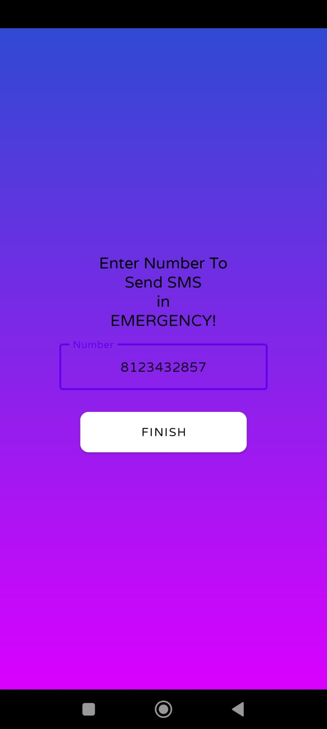
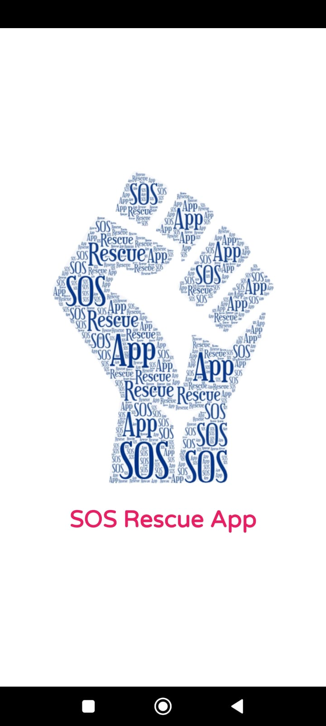

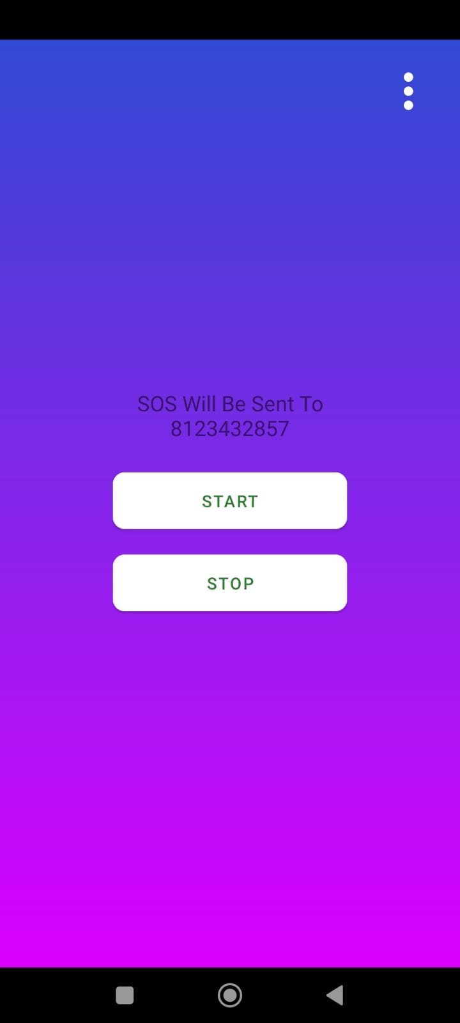
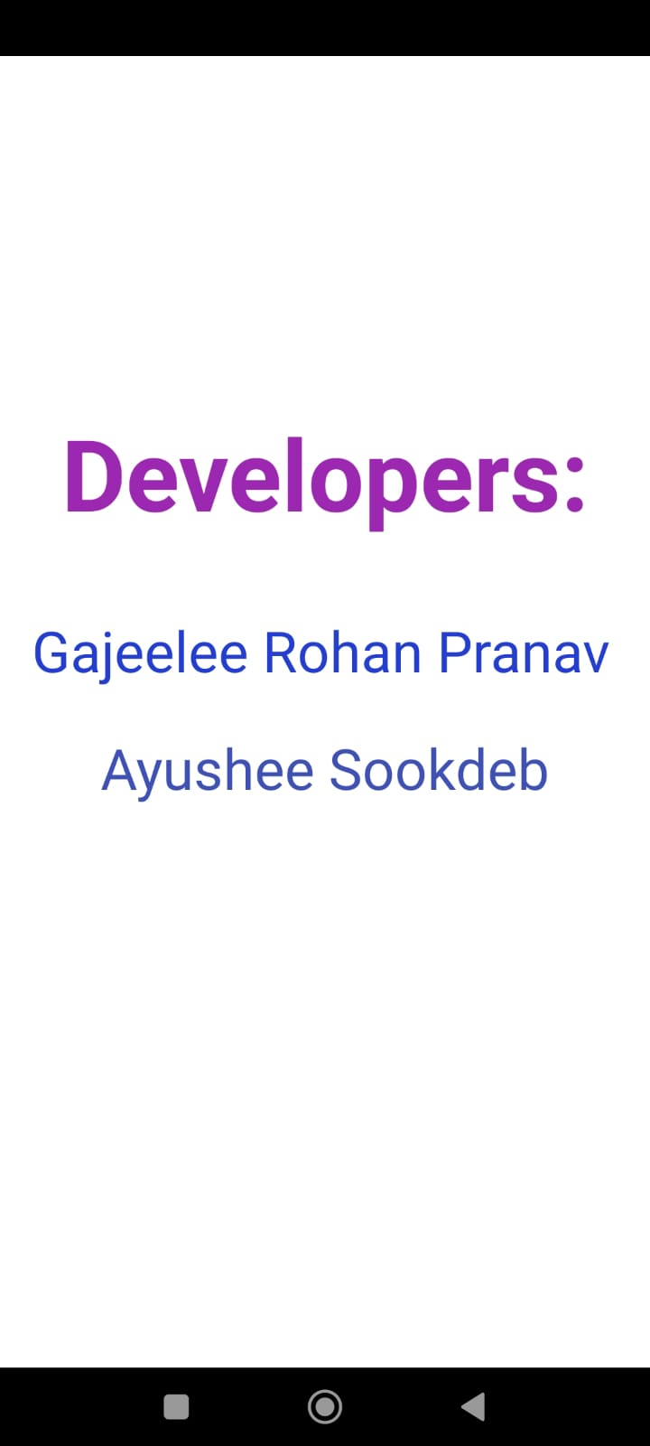

CHAPTER 7 - CONCLUSION AND ENHANCEMENTS

7.1. CONCLUSION
The main aim of our paper is to develop an application which satisfies all user requirements. The application is developed in perspective of user convenience and the friendly user interface of application which helps users without any complicated searching process and other software requirements are data security and maintainability as anyone can access with their own login so the data will be secured and the maintainance of the software will be done by the developers who will be maintain the app and so in this application with these features will help users and the user interface is also simplified such that anyone can easily use it. The main theme of this paper is to develop a user friendly interface for all users which helps them in all ways as per the query given by the user. This application must be useful to all the users who use this application and must satisfy their needs. The project work is related to advanced and security system, hoping that it will make some amount of helpfulness to the project. While the government has taken many steps, the crime rate against women is not minimizing. It is growing daily at a shocking rate. Eve teasing, harassment, domestic violence, is becoming a part of everyday life. Lot of women safety applications have been made to manage this emergency situation. This project is introducing an android app that ensures women's safety and minimizes the danger by identifying the position of the person at risk. This system is designed such a way that it will stand different from other existing app by having integrated features.

7.2. FUTURE ENHANCEMENTS
If anyone wants to extend this project then he/she can make an additional database. For instace, features like voice command, automatic audio or video recording, adding endless number of emergency contacts, GPS tracking even if there is no internet connection. Implementations of this project idea are in industrial use. Hence, this can be used for suggesting improvements in design, performance and greater usability. Apart from the industrial applications, it is a research-oriented project as well, the task of performance evaluation of different database designs, for efficiency, is in this spirit. This project that we have made is small scale but has a large development scope and we look further to the day it can be extended and used by all common people so in totality this project is an initiative taken by the youth community to contribute to the betterment of the society in whatever way we can.

CHAPTER 7 - REFERENCES

REFERENCES
www.academia.edu
www.wikipedia.com
www.slideshare.com
www.reasearchgate.net
www.my-safety-app.com
www.techonthenet.com
www.tutorialspoint.com

